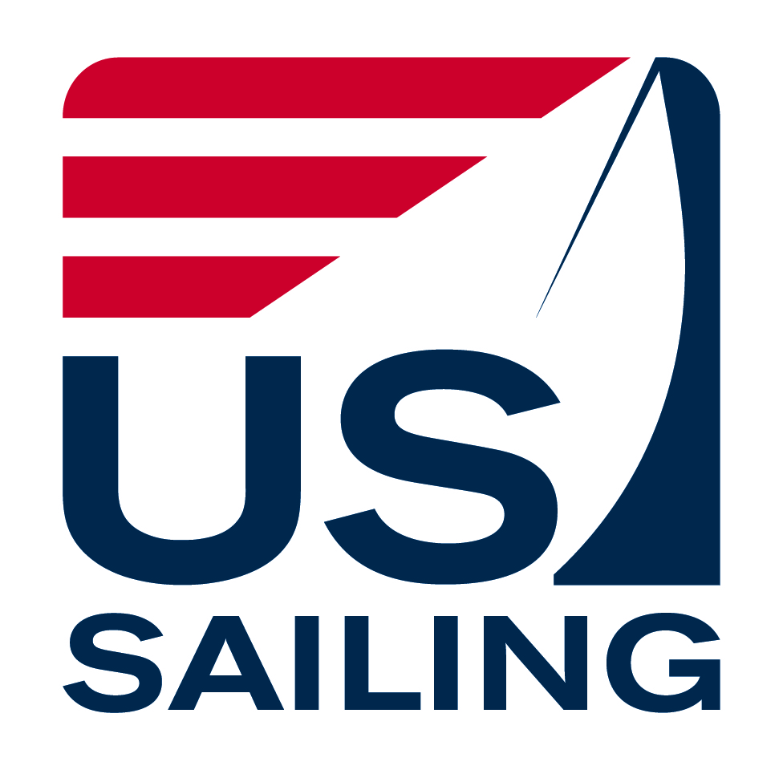
USA JUNIOR OLYMPIC SAILING FESTIVAL
Atlanta Yacht Club

May 5-6, 2018

Acworth, GA
National JO Sponsors: Gill, Sperry,
Zim & New England Ropes

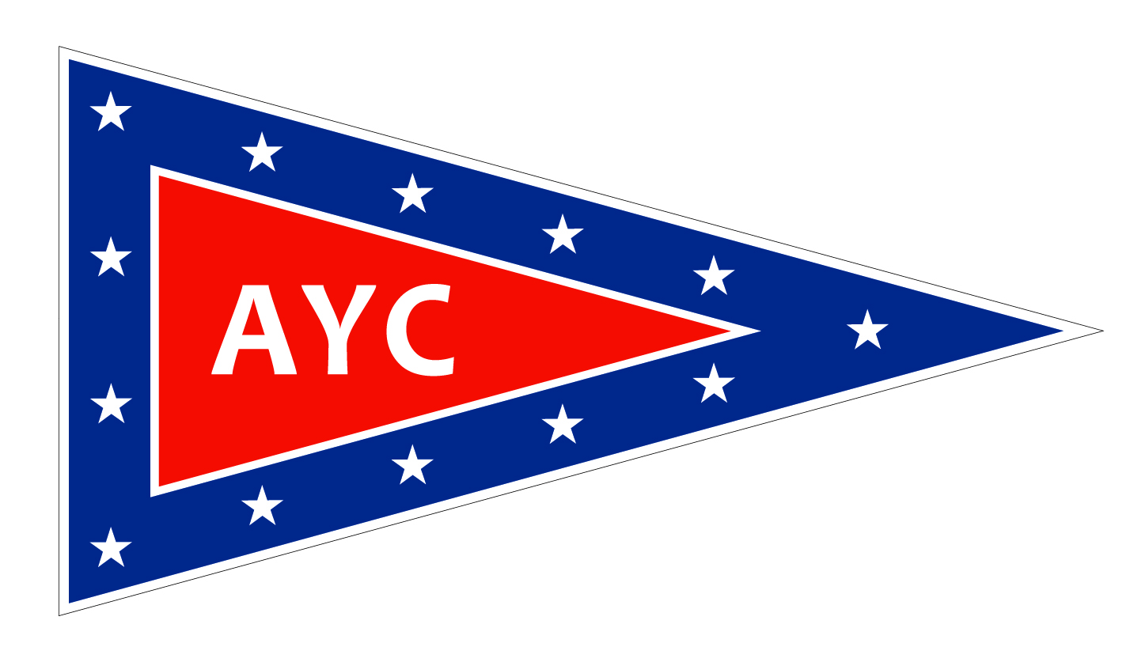

The Organizing Authority (OA) is the Atlanta Yacht Club.

N O T I C E O F R A C E

- RULES
  - The Junior Olympic Festival will be governed by the rules as defined in the Racing Rules of Sailing (RRS).
  - . For the purposes of the definition of rule, the class rules shall be the rules of the Optimist, Laser, Laser Radial, Laser 4.7 and Club and Collegiate 420 class.

  - The following rules will be changed: rule 40 and A2. These changes will also appear in full in the Sailing Instructions. Additional rules may also be changed in the Sailing Instructions.

- ELIGIBILITY & ENTRY
  - AGE
Competitors in the Optimist classes must have been born on, or after, January 1st, 2003. The Red, Blue and White Fleet assignments will be based on the competitor’s age on the first day of the Regatta. Green Fleet is not assigned by age.

Competitors in Club and Collegiate 420, Laser Radial, and Laser 4.7 classes must have been born on, or after, January 1st, 2000 and be 18 or under. Laser Standard competitors must have been born on or after Jan 1st, 1998.

  - US SAILING MEMBERSHIP
Membership in US Sailing is required for each competitor (helmsman and crew for doublehanded classes). Competitors may sign up at registration. If you are already a member, bring your membership card to registration - it will be checked. Sailors can join online at http://membership.ussailing.org/.

  - CLASS ASSOCIATION MEMBERSHIP
US Sailing recommends that competitors are members of their respective class associations (i.e., Optimist, Laser, 420, etc.).

  - GREEN REGATTA
This regatta is a Sailors for the Sea "Clean Regatta." As such, all competitors are encouraged to use non-single use water bottles and recycle all appropriate items. Competitors are reminded of rule 55 which states that competitors "shall not intentionally put trash in the water."

- BOATS/MEASUREMENT
  - Boat class Optimist will be used. Boat class Laser Full, Laser Radial and Laser 4.7 will be used. Boat class Club and Collegiate 420 with crew of helmsman and one crew.

  - Competitors are encouraged to bring their own boats. A limited number of Optis and 420s are available for charter.

  - All boats must have a floating bowline of appropriate length.

  - Each competitor will be responsible for their boats being in compliance with the class rules.
- FEES - The entry fee for all classes is $65 per boat or competitor in Optis and Lasers and $100 for both 420 skipper and crew. The entry fee includes Saturday Dinner, Sunday Breakfast, Sunday Lunch and an official USA Junior Olympic T-shirt.

- SCHEDULE OF EVENTS

Saturday

9:00 – 10:30 am
Registration
Clubhouse

10:30 am
Skippers, Coaches and Parents Meeting (Mandatory)
Clubhouse

11:30 am
First Warning – Championship Fleet
Green Fleet (to be announced at Skippers meeting)
Additional races &/or clinic to follow.

6:00 pm
Dinner at Clubhouse

“Messy de Mayo Beach Party" at the Beach Pavilion following dinner. Wear clothes that you don't mind getting a little messy. You might need a jump in the lake after THIS party!

Sunday

9:20 am First Warning Championship Fleet
Green Fleet Skippers Meeting
Additional races &/or clinic to follow.

1:00pm NO Warning Signal after this time.

After Racing - Awards ceremony with lunch
Clubhouse

The Green Fleet sailors' schedule will be the same through the Skippers meeting at which point a second, separate meeting for Green Fleet sailors will be conducted and the remainder of the schedule for that fleet will be announced.

- ADVANCE REGISTRATION - Competitors shall register in advance by registering online by going to Atlantayachtclub.org under the Junior Tab for the Junior Olympic Sailing Festival to find the link for registration and submitting it with proof of US Sailing membership. Entry deadline is May 2, 2018.

- SAILING INSTRUCTIONS - The Sailing Instructions (SIs) will be available at registration and on the web at: atlantayachtclub.org.

- SCORING - A maximum of nine races are scheduled, of which one shall be completed to constitute a series. If six or more races are sailed, a boat’s worst score shall be discarded.

- COACHES AND SUPPORT PERSONS – Coaches and Support Persons may be asked to register at the event. Coaches and Support Persons who are able to bring proof of US Sailing certification will be given appropriate access to participants and recognition. All coach / support boats shall register with the Race Committee. Each coach / support boat shall have a working VHF radio. The conduct of registered support boats and all other boats including spectator boats shall be governed by the Sailing Instructions.

- SAFETY - A US Coast Guard approved personal flotation device shall be worn, properly fastened, at all times while launching and when sailing, except for brief periods while adding or removing clothing. Failure to comply with this rule may result in disqualification. A boat retiring from a race shall notify a Race Committee vessel before leaving the course, or when that is impossible, immediately after arrival ashore. Each competitor must have a whistle attached to their PFD at all times while on the water. Each Optimist boat must have a secure loop in the end of its bow line.

An adult (Parent, guardian or designated adult) is responsible for the safety of each sailor. It is the responsibility solely of this adult to decide if the sailor should sail in the weather and sea conditions that might arise during the event. The adults supervising the competitors are ultimately responsible for the risks.

Parents not personally attending any part of the event must ensure that another adult is authorized and designated to make these decisions for their sailor, and each competitor shall indicate in writing the parent or adult representative that shall be responsible for the competitor throughout the event.

The designated adult will accept full responsibility for all actions of the competitor during any activity related to the event. This includes on-shore activities before, during, and after the Regatta.

- MEDIA RIGHTS - By participating in this regatta, a competitor (or parent/guardian if under age 18) grants to the OA and its sponsors the right in perpetuity to make, use and show, from time to time at their discretion, any photographs, motion pictures and live, taped or filmed television and other reproductions of him or her during the period of the competition without compensation.

- DISCIPLINE
  - Per US Sailing Regulation 10.03 no participant or competitor shall use or possess, either on or off the water: 1) marijuana or any other substance if possession is illegal under state or federal law; or 2) any alcoholic beverages. This regulation is in effect from date and time of arrival through date and time of departure from the venue.

  - All competitors are expected to maintain the highest level of conduct throughout the entire event. When the Protest Committee, from its own observation or a report received from any source believes that a competitor or support person may have committed a breach of a rule, good manners, or sportsmanship, or may have brought the sport into disrepute, it may call a hearing. After a proper hearing the penalty may range from a reprimand to dismissal from the regatta and additional action may be taken under RRS 69.

  - Hearings will be held generally in accordance with the recommendations of Appendix M5 of the RRS. The officers for hearing a violation will consist of the Chief Judge, acting as chairman of the hearing, the Protest Committee and the event chair.

- PRIZES
USA Junior Olympic medals will be awarded to competitors placing first through third in all divisions. Green Fleet medals will be awarded to all Green Fleet participants.

- FURTHER INFORMATION

Venue
Camping is available on club grounds, with use of clubhouse bathrooms and showers. Pets, firearms and motorcycles are not allowed on club property.

Host Club:
- Atlanta Yacht Club
7120 Yacht Club Drive
Acworth, GA 30102
Atlantayachtclub.org

Regatta Co-Chairs:
Katrina Blauvelt, 404-200-6998, Katrina.blauvelt@gmail.com
Dawn Hawkins, 678-644-4424, dawn@hawkinsplace.com

Disclaimer of Liability
Sailing is an activity that has an inherent risk of damage and injury. Competitors in this event are participating entirely at their own risk. See RRS 4, Decision to Race. The race
organizers (organizing authority, race committee, protest committee, host club, sponsors, or any other organization or official) will not be responsible for damage to any boat or other property or the injury to any competitor, including death, sustained as a result of participation in this event. By participating in this event, each competitor agrees to release the race organizers from any and all liability associated with such competitor's participation in this event to the fullest extent permitted by law.

